Naturally Creative -
Residential Retreat and non-residential spaces too,
Kirkurd, Scottish Borders, Scotland, April 16th-19th, 2026

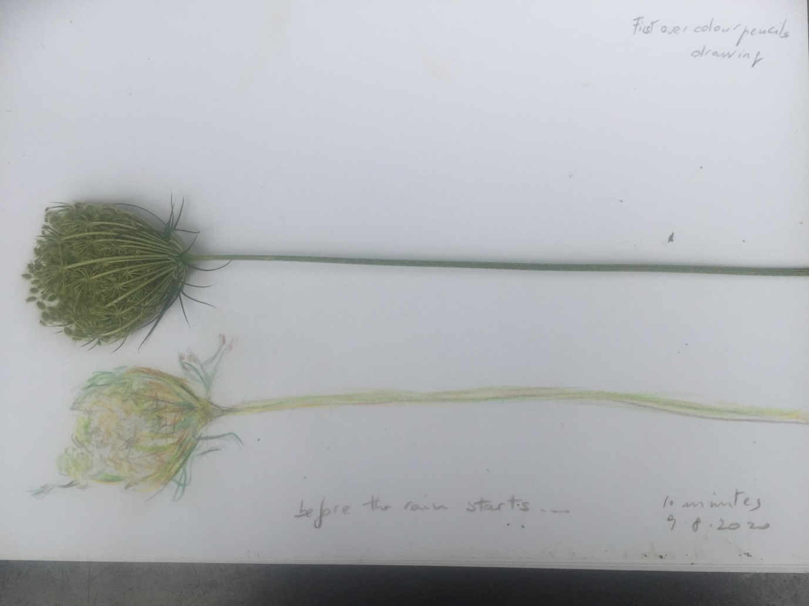
As I sit writing the description for this new retreat there are words that come to me such as Inspiration, Curiosity, Exploration, Attunement, Creativity, Surprise, Nature. I have been witnessing, exploring, being surprised by many of these companions in my teaching and practising life in the disciple of yoga and not just. Over the last twelve years or so however, the openness and inner spaciousness allowed new discoveries in. And I paid attention to the feelings these new ‘friends’ were bringing with them.
In this retreat, I would like to invite you to explore connecting, reconnecting through the senses in different ways and forms. There will be different practices that will be suggested as a possible way in, ranging from breathing techniques, yoga, walking, noticing what you are called by, resting and restoring, drawing, foraging, making from nature or simply watching.
We will attune to nature in different forms and ways and use it to enhance our sensory experiences as pathways to resource our daily lives. It is one of the hopes of these days, that we will leave not just refreshed, but more open to curiosity and exploration and playfulness, in ways that include the natural world. Being Creative in our way of living, brings a colourful varied

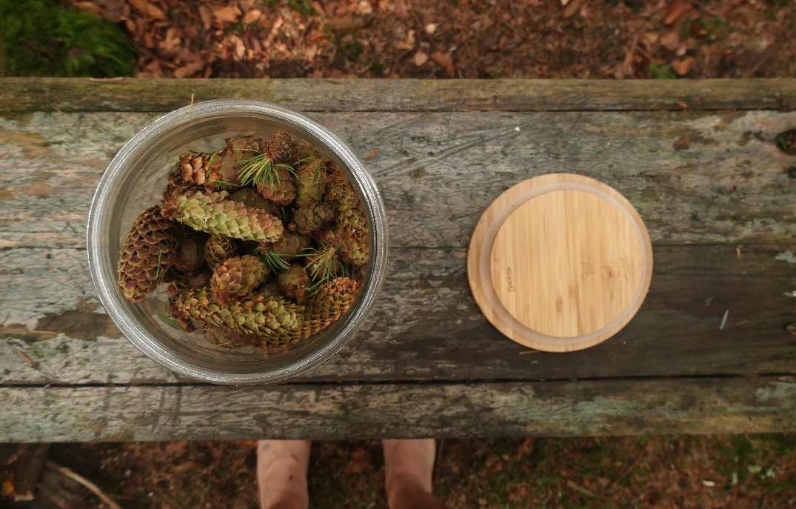
palette of rich colours and freedom which we can return to over and over and that I will be delighted to share with you.
You do not need to have any experience of either yoga, or movement, or breathwork, or drawing, or cooking….
For the residential part: all food is provided, the menu vegetarian. We cook together if possible. Vegan options may be available but we cannot cater for special diets.
Non-residential places: lunch is included. Dinner may be available and there is a separate cost for it. Please see below.
A bit about me.
I have been a yoga practitioner for over 30 years and a Yoga teacher for 25. I started organising and teaching yoga retreats in 2006 and have been running them since either as an organiser or as a teacher in Scotland, Portugal and Italy. In 2020-2021 I attended Leith School of Art, where I got the Drawing Course Award for the year. I have since committed to having my own studio, which I use both for my creative practice as well as my work as a craniosacral therapist and as a yoga mentor, teacher trainer, therapist, supervisor. Since committing to having my own studio space within the Scot-Art community, I have hosted two solo exhibitions -Finding Roots in Water’ ,2022 and ‘Earth’, 2024 as well as published a Collection of Poetry and other writings ‘Meanderings’, 2022. I owned and directed my own yoga and Therapy Studio in Edinburgh, Yoga Stable, for 19 years from 2005-2024.
A creative life, connected to nature as part of daily living is an important part of how I choose to live day by day.
What is included:
RESIDENTIAL: 3 nights’ accommodation, 3 meals per day plus dinner one arrival night and breakfast on departure day, all teas and coffee and snacks, 3 sessions of activities per day, all materials. Arrival on Thursday by 6 pm departure by 12 on Sunday.

Accommodation is offered in Single rooms, which can also be set as twin rooms. The rooms are very spacious.
Cost: Single room £580, Twin room/Double: £480 per person.
To book: £200 non-refundable deposit, unless we have a waiting list or you have someone that can fill your space. Balance due 8 weeks before retreat begins. If you are experiencing financial challenges, payment plans are available in monthly instalments with last payment due 10 weeks prior to the start (By 22nd February 2026)
NON RESIDENTIAL: What is included – Arrival dinner
Lunch on Friday and Saturday
All materials, teas and coffees and snacks.
Dinner is available for £15 extra each night for Friday and Saturday. Please let us know at time of booking, thank you.
Cost: £390 or £420 including 3 dinners and lunch on Friday and Saturday.
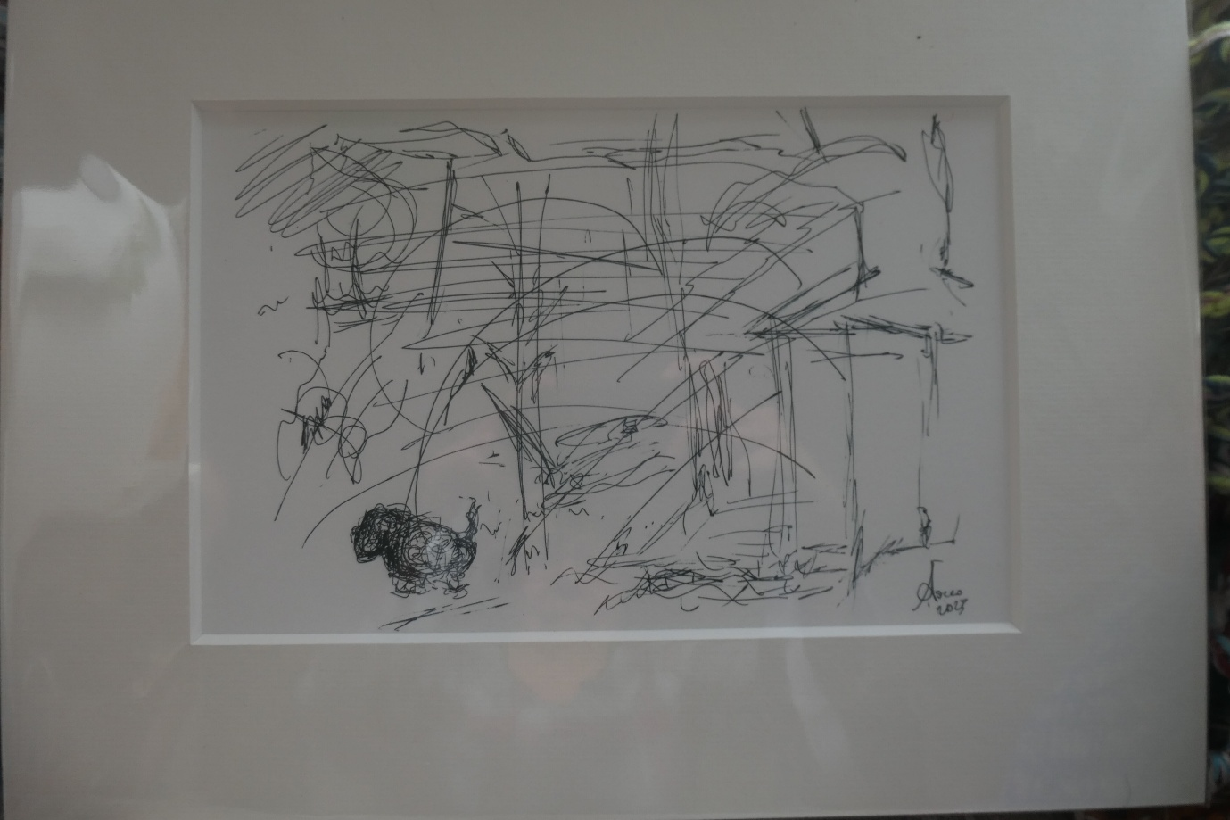
Movement – Lottie in the woods – 2023
To book, please visit https://bookwhen.com/annamaria-sacco-bodysymphonies and select the start date of the retreat. Thank you
I look forward to meeting you,
Annamaria

